Lessons from the Past: Classic Necro
David Price

"People that are really very weird can get into sensitive positions and have a tremendous impact on history."
-Vice President Dan Quayle
Not long ago, I was lamenting the loss of Dark Ritual in Extended. While it was intended to cripple the combo decks like NecroDonate, it inadvertently hurt a number of other powerful but decks. One such deck was my personal favorite, "Negator or No?" This deck featured zombies like Carnophage and Sarcomancy, shadow creatures like Dauthi Slayer and Dauthi Horror, as well as Phyrexian Negator and Hatred. Without Dark Ritual, this archetype became a shadow of it former self, unable to compete in this new Extended age. Similarly, classic Necro decks that used creatures and Drain Life to kill the opponent, instead of Donating Illusions of Grandeur, were dealt a terrible blow with the loss of Dark Ritual. Classic Necro decks were virtually nonexistent at the Masters Gateway tournament and in the Masters at this past Pro Tour - New York and I expect that trend to continue.
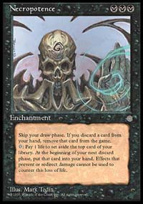
The Skull
The one deck that the banning of Dark Ritual in Extended was supposed to hurt, NecroDonate, is still alive and kicking, however, doing well on the Masters level as well as in Grand Prix Trials around the country. So what does this mean? Is Necropotence too good? If so, isn't there a classic Necro deck to be made that can compete in today's Extended?
The more I thought about it, the more I wanted to give Necro at try again. I enjoyed killing my opponent with creatures and Drain Life far more than with Donated Illusions of Grandeur or with some Enduring Renewal/Goblin Bombardment/Shield Sphere combo. Even though I am known as a red beatdown player, my first successful deck was a Necropotence deck that I played to a Top 64 finish at the very first Pro Tour - New York. Later on, I used Necro to play in a number of PTQs and I still have a great deal of love for that archetype.
So how to begin making a Necro deck without Dark Ritual? If we look back through Magic history, we'll find that one player was quite successful with a Necro deck without Dark Rituals, even going so far as to win an Extended Pro Tour. That player was Randy Buehler, now a member of Wizards of the Coast R&D, and examining his winning Necro deck is a fine place to start.
Randy Buehler, Winner of Pro Tour - Chicago 1997
Classic Necro Deck
Main Deck |  | Sideboard
Mana (24)  8 Swamp  4 Scrublands  4 Badlands  3 Gemstone Mine  2 Bad River  3 Lake of the Dead  Creatures (9)  4 Knight of Stromgald  4 Order of the Ebon Hand  1 Ihsan's Shade | Spells (27)  4 Necropotence  4 Demonic Consultation  4 Hymn to Tourach  4 Drain Life  4 Lightning Bolt  2 Incinerate  2 Firestorm  3 Disenchant

Key Concepts
At the core of Buehler's Necro deck are cheap efficient creatures. The deck uses Knight of Stromgald and Order of the Ebon Hand for early beats. Their primary purpose is to trade with opposing creatures or draw out Lightning Bolts, but they can sometimes just win the game. These creatures, along with Ihsan's Shade, were particularly powerful in the old Extended environment because Swords to Plowshares was the removal spell of choice and Protection from White meant that they couldn't be targeted by it.
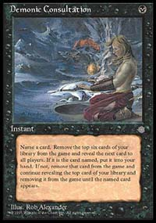
While the deck is casting black pump knights and threatening the opponent, it is really just looking to find and cast Necropotence. With 4 Demonic Consultations and 4 Necropotence, it isn't usually too hard to find. If the opponent is forced to tap out to deal with a Knight, all the better, as that makes it more difficult for him or her to stop the Necropotence from entering play. In addition, the deck contains Hymn to Tourach to both disrupt the opponent's strategy and help get the Necropotence into play.
So what next, once the Necro is in play? The deck uses Lightning Bolt, Incinerate, and Firestorm to kill the opposing creatures, although in combination with a quick Knight of Stromgald or Order of the Ebon Hand, they can also be used to finish off the opponent. The real finisher, however, is a Lake of the Dead fueled Drain Life, which can not only deal a tremendous amount of damage to the opponent, but it gives the Necro deck more life with which to draw cards.

So What Next?
Many of the specific cards used in Randy Buehler's Necro deck may no longer be the right choice for today's Extended. Hymn to Tourach and Lightning Bolt have been rotated out and Knight of Stromgald may no longer be the best choice for cheap efficient creatures. In addition, since the introduction of Wasteland, Price of Progress, and Back to Basics to Extended, it has become a great deal more dangerous to use that many non-basic lands. Many decks these days tend to use only four or eight non-basics, limiting the effect of these non-basic land hosers.
In order to get a better idea of which spells and creatures to use in a modern Extended deck, lets take a look at Brian Davis' Necro deck, which he used to finish 2nd in last years Extended Pro Tour, PT-Chicago 1999. Brian Davis encountered some fierce competition along the way, losing to Bob Maher, Jr. and his CounterOath deck in the finals. Many competitors and spectators felt that Davis had a better chance than Maher to win that final match.
Brian Davis, 2nd place at Pro Tour - Chicago 1999
Classic Necro Deck
Main Deck |  | Sideboard
Mana (26)  18 Swamp  4 Wasteland  4 Dark Ritual  Creatures (2)  2 Skittering Skirge | Spells (32)  4 Necropotence  3 Demonic Consultation  4 Duress  4 Unmask  4 Drain Life  4 Corrupt  4 Contagion  3 Spinning Darkness  2 Nevinyrral's Disk

This deck is somewhat different from Buehler's Necro deck, using fewer creatures and more Drain Life-type cards, with both Drain Life and Corrupt as finishers. However, it does give us some pointers about where to look for replacement cards. For instance, instead of the old Hymn to Tourach, Davis uses both Duress and Unmask. While certainly not as powerful, these two spells seem to fill the shoes of Hymn to Tourach adequately. In addition, when Davis was looking for a cheap efficient creature, he decided on Skittering Skirge. This 3/2 flier for two black mana is incredibly efficient; its drawback being that if you play additional creatures, it is buried. Still, not every aspect of this deck can be applied to Buehler's Necro deck. For instance, Lake of the Dead interacts very poorly with Corrupt (which deals damage based on the number of Swamps in play), so one of these two will have to go by the wayside.
Lets see how our new Necro deck is looking.
Swamp, Necropotence, Drain Life, and Demonic Consultation - These are the common links between the two decks and I expect that we'll be using a lot of each of these cards. These are the core components of the classic Necro deck.
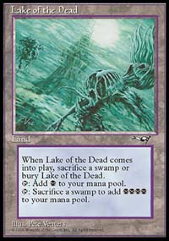
Lake of the Dead - Without Dark Ritual, we're going to have to rely on Lake of the Dead to pump up our Drain Life to kill the opponent. Somewhat scary in an environment where Wasteland is present, you can still get one use out it late in the game, which may be all that you need.
Mox Diamond - One of the key cards that modern NecroDonate decks use to speed up their mana is Mox Diamond. Not exactly a replacement for Dark Ritual, it will help our Necro deck get off to a quicker start and it can help us make use of early or redundant Lakes of the Dead.
Skittering Skirge - A 3/2 flier for two black mana, this creature is more efficient than the traditional Knight of Stromgald. While you can't pump up the Skirge, it does have evasion, which is incredibly important in these days of tournament viable walls like Wall of Blossoms and Wall of Roots.
Chimeric Idol - Since Skittering Skirge's drawback makes us less inclined to use real creatures, we can use this artifact turned creature to make up the rest of our early threats in our Necro deck. Similar to the Steel Golems that were used by Standard and Extended Necro decks shortly after Weatherlight was released, Chimeric Idol is a reasonably efficient artifact creature and unlike the Golem, it combos well with the Skirge.
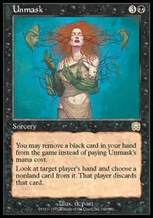
Duress and Unmask - Taking a cue from Brian Davis' Necro deck, no modern Necro deck should be without these cards. They can be used to disrupt combo decks, remove powerful burn spells from the hands of red mages and help take the counterspells away from blue players. Rarely are these two cards not useful.
Urza's Rage - Not as cheap as a Lightning Bolt or an Incinerate, this spell is particularly good against blue mages, providing us with an uncounterable way to take down Ophidian. In addition to being used to kill attacking and blocking creatures, in combination with Lake of the Dead, Urza's Rage with the kicker can be used to finish off the opponent.
Badlands - An oldie, but a goodie. While it hurts to have this land destroyed by Wasteland or to have too many on the board when the opponent casts Price of Progress, it is a necessary sacrifice in order to let us use Urza's Rage in the main deck and give us access to Pyroblast in the sideboard, a powerful sideboard card against Stasis, blue control, and Necro Donate.
LakeRage
A somewhat classic Necro deck
Main Deck |  | Sideboard
Mana (28)  4 Mox Diamond  4 Lake of the Dead  4 Badlands  16 Swamp  Creatures (8)  4 Skittering Skirge  4 Chimeric Idol | Spells (24)  4 Necropotence  4 Demonic Consultation  4 Duress  4 Unmask  4 Drain Life  4 Urza's Rage

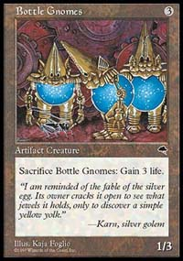
Got sideboard?
So is this beast ready to win an Extended Grand Prix? Maybe, maybe not. It excels against the five-color control deck that Zila used in the Masters. It has a good shot against Survival based decks and that can only be helped by sideboarding, where the Necro deck has access to Perish, a powerful card against base green decks, and Pyroblast to take down Tradewind Rider and stop Force of Will. It can hold its own against the new brand of NecroDonate decks and Pyroblasts out of the sideboard won't hurt that matchup either. Red burn still gives it fits, but everything has to lose to something, right? It might even be able to get past those if it has enough Bottle Gnomes in the sideboard.
While it may not be perfectly tuned, this Necro deck makes me think that black is still very viable, despite the bannings. By examining some of the successful Necro decks of the past, we've been able to come up with a reasonably good Necro deck for the current Extended environment. Who knows, with a bit more tuning and playtesting, LakeRage could make some waves.

